Dear Business Owner:

If there is an emergency at your place of business when you are not present, it is important that the Police Department have current contact information on individuals who have access and are able to respond to your business during that emergency.

**We are currently updating our emergency response information and request a Business Index card be filled out and returned to:**

**Brentwood Police Department Or Fax: (925) 809-7799**

**9100 Brentwood Blvd. Email:** [**police@brentwoodca.gov**](mailto:police@brentwoodca.gov)

**Brentwood, CA 94513**

You may contact the Police Department and request a blank card be sent to you at any time throughout the year in order to update your information. You may also go onto the Police Department’s website at [www.brentwoodca.gov/gov/police](http://www.brentwoodca.gov/gov/police) and print a copy of the letter/card.

Thank you for your cooperation. If you have any questions, please contact Jaylene Walker at the Brentwood Police Department at (925) 809-7701.

Sincerely,

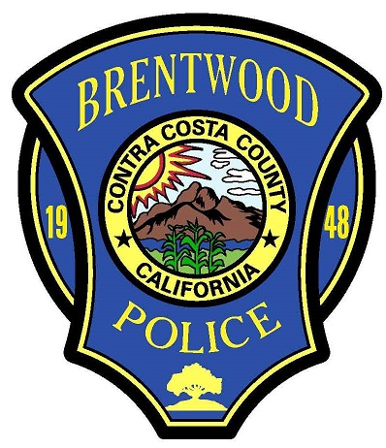

Brentwood Police Department

Business Index Card

Name of Business _________________________________

Address ________________________________________

Owner’s Name____________________________________

Contact Number ___________________________________

Emergency Contact Name #1___________________________

Emergency Contact Number ___________________________

Emergency Contact #2 _______________________________

Emergency Contact Number ___________________________

Tim Herbert

Chief of Police